4CS001
Introductory Programming
&
Problem-Solving

Lab Report

Name: Sagar Mishra
Group: 4
Student ID: np02cs4a250038

Module Leader Tutor
_______________ ______________
Table of Contents
Lab | Lab Title | Page No. | Tutor’s Signature
7 | 1. Part 1 5  1.1 Explain the concept of file modes in Python. Provide a brief description of at least three file modes commonly used in file handling. How does the choice of mode affect the way a file is opened and processed? 5  1.2 Discuss the difference between writing and appending to a file in Python. When would you choose one over the other? Provide an example scenario where appending to a file is more suitable than writing to it. 6  1.3 Enumerate and explain three best practices for proper file handling in Python. Consider aspects such as opening and closing files, error handling, and resource management. 7  1.4 Discuss the potential consequences of not closing a file explicitly. How does Python handle file closing when using the with statement, and why is it considered a good practice in file handling? 9  2. Part 2 10  2.1 Create a program in Python that opens a file named 'datafile.txt' for reading and assigns identifier input_file to the file object created. 10  2.2 Create a program in Python that opens a file named 'datafile2.txt' for writing and assigns identifier output_file to the file object created. 10  2.3 Assume that input_file is a file object for a text file open for reading, and output_file is a file object for a text file open for writing. Explain the contents of the output after the following code terminates: 10  empty_str = '' 10  line = input_file.readline() 10  while line != empty_str: 10  output_file.write(line + '\n') 10  line = input_file.readline() 10  2.4 Identify the error in the following code: 11  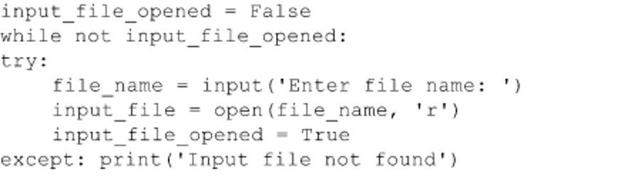 11  3. Part 3 12  3.1 Write a Python function called reduce_spaces that is given a line read from a text file and returns the line with all extra space characters removed: 12  ‘This line has extra space characters’ → ’This line has extra space characters’ 12  3.2 Write a Python function named extract_temp that is given a line read from a text file and displays the one number (integer) found in the string: 12  ‘The high today will be 75 degrees’ → 75. 12  3.3 Write a Python function named check_quotes that is given a line read from a text file and returns True if each quote character in the line has a matching quote (of the same type), otherwise returns False. 13  ‘Today’s high temperature will be 75 degrees’ → False 13  3.4 Write a Python function named interleave_chars that is given two lines read from a text, and returns a single string containing the characters of each string interleaved: 13  ‘Hello’, ‘Goodbye’ → ‘HGeololdobye’ 13  3.5 Give a for loop that counts all the characters in a string assigned to a variable line, except blanks and the newline character. 14  3.6 For a variable month which contains the full name of any given month, give an expression to display just the first three letters of the month. 14  3.7 Give an expression that displays True if the letter ‘r’ appears in a given month name stored in a variable month, otherwise displays False. 14  3.8 Give an expression for determining how many times the letter ‘r’ appears in a given month name stored in a variable month. 15  3.9 For a person’s first name stored in variable first_name, and last name stored in variable last_name, give an expression that displays the person’s name formatted exactly as follows: Jones, William. 15  3.10 Give an instruction that determines if a given social security number represented as a string and stored in variable ss_num, contains any non- digits. 15  3.11 Give an instruction that determines the index of the ‘@’ character in an email address stored in variable email_addr. 16  3.12 For a variable named date containing a date in the form 12/14/2012, give an expression that replaces all slashes characters with dashes. 17  3.13 For a variable named err_mesg that contains error messages in the form ** error message **, give an expression that produces a string containing the error message without the leading and trailing asterisks and blank characters. 17  4. Part 4 18  4.1 Write a Python program that encrypts and decrypts text files using a substitution cipher. Your program should ask the user for the name of a text file and whether they would like to encrypt or decrypt. Once the process is complete, you should write the output to a new text file with a modified name: 18  This program will encrypt and decrypt text files 18  Enter (e) to encrypt a password, and (d) to decrypt: e 18  Enter the name of a text file to encrypt: hello.txt 18  Output written to: encrypted_hello.txt 18  Your program should catch exceptions and print helpful error messages. You should use your solution to Coding Challenge 04 to help you. 18

Name / Sign of Module Leader Name / Sign of Module Leader

_________________ ___________________
Date: Date:

Part 1

Explain the concept of file modes in Python. Provide a brief description of at least three file modes commonly used in file handling. How does the choice of mode affect the way a file is opened and processed?

- In python, file modes determine the operation to be performed on file, when using built-in open() function. The mode is passed as the second argument in open() function: open(filename, mode). The default mode is readtext i.e. (‘rt’).
For example:
file = open (“filename.txt”, “r”)
with open (“filename.txt”, “r”) as file:
Some commonly used file modes are:
- r – Read mode :
The read mode(r) is used to open a file for reading only. When the file dose not exist an error occurs. File pointer starts from beginning.
file = open("data.txt", "r")
content = file.read()

- w – Write mode:
The write mode(w) is used to open a file for writing mode. It creates a new file if file does not exist. It overwrites the existing content if the file exists. The previous data gets erased before writing new content.
file = open("data.txt", "w")
file.write("Hello, Python!")

- a – Append mode:
The append mode(a) is used to open a file for writing at the end. It creates a new file if file does not exist. The new data is appended at the end of the file without removing old content. Pointer starts at the end of the file.
file = open("data.txt", "w")
file.write(“\nNew data is addded here without removing old content.")

- r+ Read and Write mode:
The r+ mode is used to open a file for both reading and writing. If the file does not exist en error message is shown. File pointer starts at the beginning. Allow modifying existing content without deleting the file.
file = open("data.txt", "r+")
The file mode determines how a file is accessed, whether it must exist, whether data is preserved or overwritten, and where reading or writing begins. Choosing the proper file mode ensures correct file processing and prevent errors and data loss.

Discuss the difference between writing and appending to a file in Python. When would you choose one over the other? Provide an example scenario where appending to a file is more suitable than writing to it.

- Differences between writing and appending to a file in python are given below:
Writing to a file | Appending to a file
It is used when we have to delete the existing content and write new data or overwrite the existing one from the beginning of the file. | It is used when we have to add data to the file at the end of its own existing content.
It can be used to create fresh files and reports. | It can be used to create logs, records and history files.
Syntax:  with open("data.txt", "w") as file:  file.write("This is new content.") | Syntax:  with open("data.txt", "a") as file:  file.write("\nThis is additional content.")
Writing is preferred over appending mode when we want a clean start and do not need any existing data. | Appending is preferred over writing mode when existing ata must be preserved and new data needs to be added continously.

Enumerate and explain three best practices for proper file handling in Python. Consider aspects such as opening and closing files, error handling, and resource management.

- Proper file handling is important to prevent data loss, runtime errors and resources leaks. Some aspects are given below:

- Opening and closing file:
There are commonly two ways to open a file:
- Using with statement:
with open ("data.txt", "r") as file:
content = file.read()
In this, a file is automatically closed after the block of code is executed, even if any error occurs. This method prevent data loss, avoids resource leak and make code cleaner and safer.

- Manual opening and closing the file:
file = open("data.txt", "r")
content = file.read()
file.close()
In this the file is opened manually and there a risk of forgetting to close the file afterwards. The file should have to be closed explicitly using “close()”. The resource may be wasted if we forget to close the file.

Therefore, the best way to open and close a file is by using with statement.

- Error handeling:
In file handling, errors can occur, such as:
- File does not exist.
- The file name id incorrect.
- The program does not have permission to access the file.

Therefore, a proper error handling is necessary to prevent program from crashing. For this python uses exception handling with try-except.

Syntax:
try:
with open ("data.txt", "r") as file:
content = file.read()
except FileNotFoundError:
print ("File not found.")
except IOError:
print ("An error occurred while accessing the file.")

Here try block contains code that might cause an error, and python firstly attempts to open and read the file.
The except FileNotFoundError occurs only when file does not exist and prevents the program from stopping suddenly. This block prints “File not found” if respective error occurs.
The except IOError deals with other input output problems like permission issue or file corruption. This block prints “An error occurred while accessing the file” if respective error occurs.

- Resource Management:
Resource Management in python refers to proper use, control and release of system resource such as files, memory and file handles while a program is running. Good resource management ensures that the system remains efficient, stable, and free from error.
- File handle (connection to the file)
- Memory to read and write data
- System level access to the file
To manage a resource properly we can follow these things:
- We should open a file only when needed.
- We can close the file to free resources that frees the file handle and allows the other program to access the file.
- Choosing the best file mode according to our task that is needed to be performed on it.

Simply we have to open the file perform the task and close that file for proper resource management.

Discuss the potential consequences of not closing a file explicitly. How does Python handle file closing when using the with statement, and why is it considered a good practice in file handling?

- The consequences of not closing a file explicitly are given below:

    - Open file consists of system resources (file handles and memory) and if many files remain open the program may exceed system limit and fail which can cause resource leak.
    - Data written to a file may remain in memory buffer and if file isn’t closed, buffered data might not get saved to the disk.
    - Some OS lock the file while they are open due to which other programs may be unable to access the file.
    - When a file is opened in python and not closed properly, the program may behave in unexpected or unreliable ways.

The Good practice of opening a file is by using with statement that uses a context manager. When the block ends, python automatically closes he file i.e. Python automatically calls file.close() and all associated resource are released safely.
Syntax:
with open ("data.txt", "r") as file:
content = file.read()
File is automatically closed here as the block ends and calls file.close() automatically after execution of the block.

Part 2
- Create a program in Python that opens a file named 'datafile.txt' for reading and assigns identifier input_file to the file object created.

- Code:
with open ("datafile.txt", "r") as input_file:
#Here goes the task need to do on this file.

- Create a program in Python that opens a file named 'datafile2.txt' for writing and assigns identifier output_file to the file object created.

- Code:
with open ("datafile.txt", "w") as output_file:
#this part creates file on non-existence condition or overwrites the content if file exists
- Assume that input_file is a file object for a text file open for reading, and output_file is a file object for a text file open for writing. Explain the contents of the output after the following code terminates:

empty_str = ''

line = input_file.readline()

while line != empty_str:

output_file.write(line + '\n')

line = input_file.readline()
Output
Line 1

Line 2

Line 3
- The readline() reads a line at a time from input_file and store it into a variable named line. While loop is executed until the readline() reads empty line. .write(line + ‘\n’) writes the line into output_file and extra empty line.
The program simply copies the content in input_file one line at a time and paste it into output_file adding a new empty line after each line.

- Identify the error in the following code:


- The file needs to be closed explicitly which is not done in this program.
- The while loop is used but it won’t work for try-except because there is an indentation error which is mandatory in python. The try-except bock must be idented inside the while loop.
- except catches all error at the same time and says “file not found” for any type of error. For example: if there is any mistake like permission error or any other error it will show the same message for that too.

Corrected code:
input_file_opened = False
while not input_file_opened:
try:
file_name = input ("Enter file name: ")
with open(file_name,"r") as input_file:
input_file_opened = True
except FileNotFoundError:
print("Input file not found")
except PermissionError:
print("No permission to open the file")

Part 3
- Write a Python function called reduce_spaces that is given a line read from a text file and returns the line with all extra space characters removed:

‘This line has extra space characters’ → ’This line has extra space characters’
- Code:
def reduce_spaces(line):
return " ".join(line.split())
line = "This line has extra space characters"
print(reduce_spaces(line) + “.”)

- Write a Python function named extract_temp that is given a line read from a text file and displays the one number (integer) found in the string:

‘The high today will be 75 degrees’ → 75.

- Code:
def extract_temp(l):
num = 0
for ch in l:
if '0' <= ch <= '9':
num = num * 10 + (ord (ch) – ord ('0'))
print(num)
line = "The high today will be 75 degrees"
extract_temp(line)



- Write a Python function named check_quotes that is given a line read from a text file and returns True if each quote character in the line has a matching quote (of the same type), otherwise returns False.

‘Today’s high temperature will be 75 degrees’ → False

- Code:
def check_quotes(line):

single = 0
double = 0
for ch in line:
if ch in ("'", "’", "‘"):
single += 1
elif ch in ('"', '“', '”'):
double += 1
return single % 2 == 0 and double % 2 == 0
line = "Today’s high temperature will be 75 degrees" #taken from a text file
print (check_quotes(line))

- Write a Python function named interleave_chars that is given two lines read from a text, and returns a single string containing the characters of each string interleaved:

‘Hello’, ‘Goodbye’ → ‘HGeololdobye’
- Code:
def interleave_chars(s1, s2):
result = ""
line1, line2 = s1.replace(" ",""), s2.replace(" ","")
for i in range (min(len(line1),len(line2))):
result += line1[i] + line2[i]
result += line1[i+1:] + line2[i+1:]
return result
with open("data.txt","r") as file:
line1 = file.readline()
line2 = file.readline()
print (interleave_chars(line1, line2))

- Give a for loop that counts all the characters in a string assigned to a variable line, except blanks and the newline character.

- Code:
line = "H e l l o W o r l d \n"

count = 0
for ch in line:
if ch not in (" ", "\n"):
count+=1
print (count)

- For a variable month which contains the full name of any given month, give an expression to display just the first three letters of the month.

- Code:

def mon(x):
return x [0:3:1]
month = input ("Enter the month name:")
print(mon(month))
- Give an expression that displays True if the letter ‘r’ appears in a given month name stored in a variable month, otherwise displays False.

- Code:
def check_r(x):
return "r" in x
month = input("Enter the month name:")
print(check_r(month))



- Give an expression for determining how many times the letter ‘r’ appears in a given month name stored in a variable month.

- Code:

def count_r(x):
return x.count("r")
month = input("Enter the month name:")
print(count_r(month))
- For a person’s first name stored in variable first_name, and last name stored in variable last_name, give an expression that displays the person’s name formatted exactly as follows: Jones, William.

- Code:
def joinName(a,b):
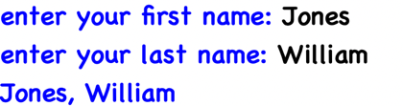
return a + ", " + b
first_name = input ("enter your first name: ")
last_name = input ("enter your last name: ")
print (joinName (first_name, last_name))
- Give an instruction that determines if a given social security number represented as a string and stored in variable ss_num, contains any non- digits.

- Code:
Or,
We can also replace line number 2 to 5 with:
return not a.isdigit()
def check_nondigit(a):
for ch in a:
if not ('0' <= ch <= '9'):
return True
return False
ss_num = input ("Social security number: ")
print (check_nondigit (ss_num))



- Give an instruction that determines the index of the ‘@’ character in an email address stored in variable email_addr.

- Code:
def check_index(email):
email_addr = 0
for ch in email:
if ch == "@":
print("Index of @ character in the given email address is", email_addr)
return
email_addr += 1
print("No @ character found in the email address")
email_address = input("Enter your email adddress: ")
check_index(email_address)

OR,

def check_index(email):
email_addr = email.find("@")
print("Index of @ character in the given email address is", email_addr)
email_address = input("Enter your email adddress: ")
check_index(email_address)



- For a variable named date containing a date in the form 12/14/2012, give an expression that replaces all slashes characters with dashes.

- Code:
def remove_slashes(date):
return date.replace("/","")
date = "12/14/2012"
print (remove_slashes (date))



- For a variable named err_mesg that contains error messages in the form ** error message **, give an expression that produces a string containing the error message without the leading and trailing asterisks and blank characters.

- Code:
err_mesg = "** error message **"
print (err_mesg.replace("**"," "))



Part 4
- Write a Python program that encrypts and decrypts text files using a substitution cipher. Your program should ask the user for the name of a text file and whether they would like to encrypt or decrypt. Once the process is complete, you should write the output to a new text file with a modified name:

This program will encrypt and decrypt text files

Enter (e) to encrypt a password, and (d) to decrypt: e

Enter the name of a text file to encrypt: hello.txt

Output written to: encrypted_hello.txt

Your program should catch exceptions and print helpful error messages. You should use your solution to Coding Challenge 04 to help you.

- Code:
Lets encrypt the file below:
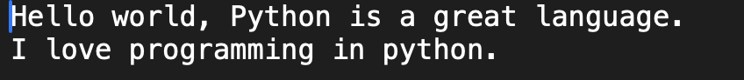
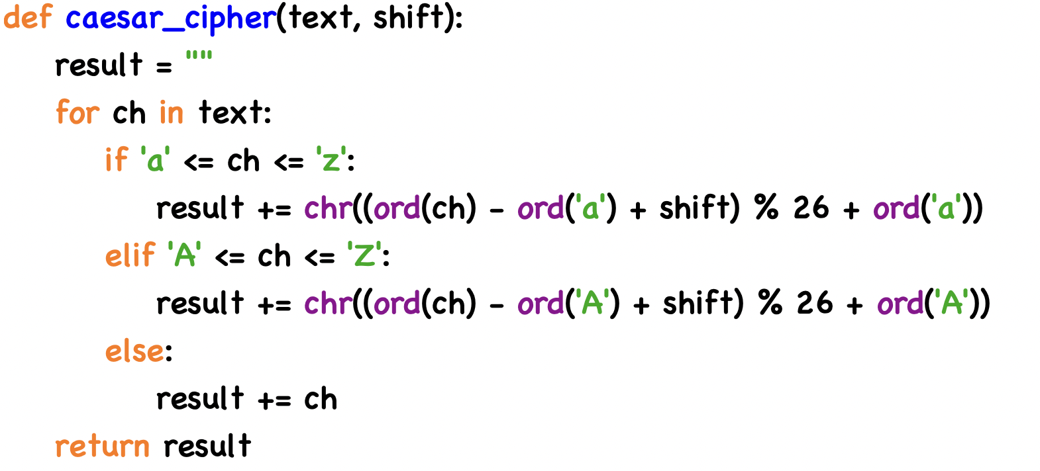
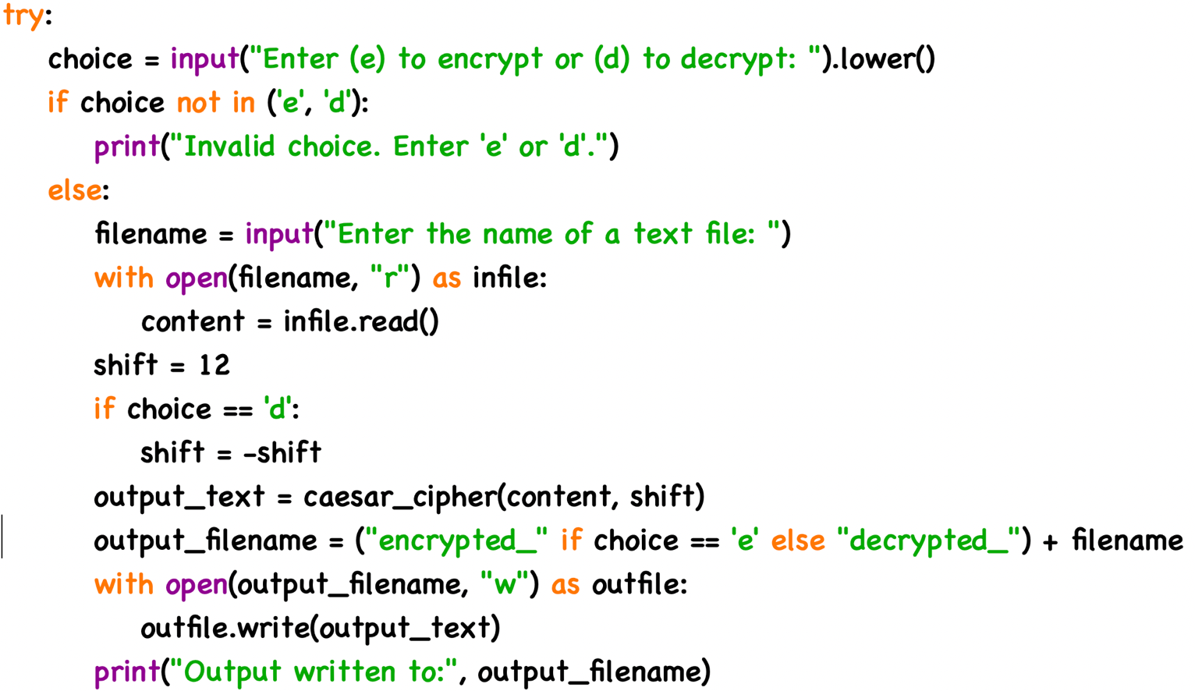
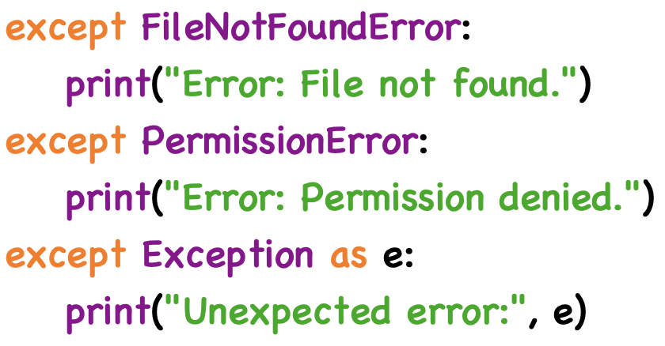

Output:
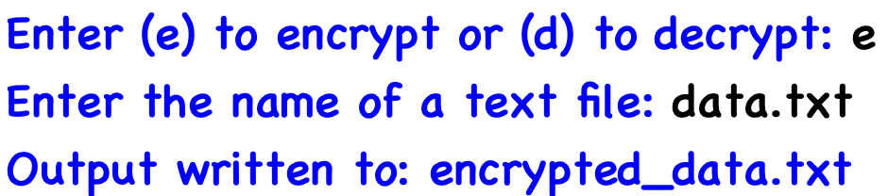
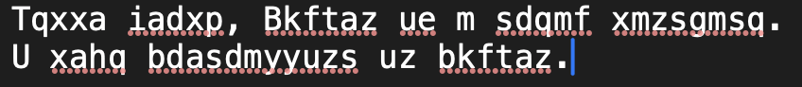

🎯Aims

- The main aim of this report is to develop a set of python program that demonstrate effective file handling, string processing and basic encryption technique. We learnt to manipulate text data file in different ways using it different modes to operate with file according to the need. We also learnt string operation and different built-in functions to use to manipulate a string. We combined string processing and file handling to do various productive tasks.

📌Objectives

- To open a file safely in different modes, read and write from the file and handle the exception properly.
- To use string operation to do different types of text processing like reducing extra spaces, finding numeric value, interleaving characters from two strings, etc.
- To check validations using .isdigit(), .find(), etc. both manually and by using the function.
- To encrypt or decrypt a file using substitution cipher and using it to implement to a text file and allow user to interact with it.
- To use function to modularize code for readability and reuse.
- To get user interactions for inputs such as filename, text or operation choice.
- Display clear output and handle error messages properly.

--- THANK YOU ---

